Electronics and Computer Science

Faculty of Physical Sciences and Engineering

University of Southampton

Iovana Pavlovici

01.05.2017

Continuous Feedback System

Project supervisor: David Millard

Second examiner: Elena Simperl

A project report submitted for the award of

BSc Computer Science

**Abstract**

There are various existing methods for collecting student feedback on aspects such as quality of teaching. However, it is impossible to collect meaningful results when participation rates are very low. University classes have been getting larger and with so many students enrolled on a course, the University and the lecturers need to find a way of communicating to their students. The purpose of this project is to propose a continuous feedback method to engage students in providing feedback. The design proposed attempts to improve interaction between students and lecturers and ultimately increase both student and lecturer satisfaction. By developing a continuous feedback tool for students and lecturers I explored a different method of collecting feedback.

**Contents**

Abstract 2

Contents 3

Acknowledgements 5

1 Introduction 6

1.1 Problem 6

1.2 Goals 6

1.3 Scope 6

2 Background and Report of Literature Research 8

2.1 What is Feedback? 8

2.2 What is University Feedback? 8

2.3 What is the purpose of a feedback system? 8

2.4 How is it implemented? 8

2.5 Challenges 9

2.6 Solutions 10

2.7 Feedback Platforms 11

3 Project Planning 13

3.1 Iterative Design 13

3.2 Participatory Design 14

3.3 Gantt Chart 14

3.4 Risk Analysis 15

4 Design 16

4.1 Iteration One 16

4.1.1 Stakeholder Analysis 16

4.1.2 Personas 18

4.1.3 Analysis of feedback system 19

4.1.4 Feedback system design proposal 20

4.1.5 Wireframes 20

4.2 Iteration Two 22

4.2.1 Product Backlog 23

4.3 Iteration Three 24

5 Implementation 25

6 Testing 28

6.1 Black-Box Testing vs White-Box Testing 28

6.2 Scenario Testing 29

7 Evaluation 30

7.1 Goals 30

7.2 Approach 30

8 Reflection 35

9 Conclusion and Future Work 36

10 References 38

11 Appendices 41

A. University of Southampton Module Survey Questions 41

B. Updated Gantt Chart 43

C. Testing scenarios 43

D. Source code 46

E. Participation Email 46

F. Ergo Application 47

G. Requirements Analysis 54

H. Screenshots 55

55

**Acknowledgements**

First, I would like to thank my supervisor, David Millard, for the help and support given throughout the year. I would also like to thank Rikki Prince for helping with the evaluation, and the lecturers and students who made time to participate in the study.

**1 Introduction**

1.1 Problem

In the past few decades classroom sizes have been growing larger resulting in increased workload for lecturers (Barker and Pinard, 2014). This has a negative effect on the level of interaction between students and lecturers and can decrease student satisfaction. A method of communication (disregarding emailing services) is the use of the feedback system implemented by Universities.

The ECS department of the University of Southampton currently uses three methods of feedback collection: informal feedback, SSLCs (Staff student liaison committees), and module surveys. Informal feedback cannot be properly investigated which results in students not being aware of any changes that result. Both course representatives’ actions (SSLC members) and module surveys suffer from lack of student interest. Module surveys are sent out at the end of each Semester and suffer from low participation rates due to a broken feedback loop. This occurs because in most cases students are not updated on the changes that followed, while course representatives are rarely approached by students.

Lecturers do not receive enough feedback upon which they could act towards improving their lectures. This then feeds into students not observing any actions taken on their feedback and resigning from filling in module surveys. Students don’t see any changes made which causes the problem to become a self-perpetuating loop whereby students become disinterested in giving feedback and so lecturers don’t receive enough information to make any changes.

1.2 Goals

The main priority of the project is to investigate whether continuous feedback is an effective method of feedback communication and how can it be implemented to fill in the gaps of the current feedback system. My research on current feedback methods provided information on the various requirements students and lecturers could need in a feedback system. By using these a design has been produced which constitutes the foundation of the prototype to be built. The goal of the prototype is to create a medium for students to communicate with lecturers while considering the issues that could arise. The main challenges of an online tool for continuous feedback include student anonymity, overwhelming the lecturer with information, and cyberbullying. There are also challenges which arise with systems designed for students, particularly student participation, because it can be difficult to engage their interest and gain momentum.

1.3 Scope

The research of the current feedback methods is mainly focused on the methods used by the ECS Department from the University of Southampton. The participants were also chosen from this department due to low participation rates in the module evaluation surveys. Due to time constraints, it was not possible to implement all features brought forward by the stakeholders and the requirements had to be prioritised based on importance.

**2 Background and Report of Literature Research**

2.1 What is Feedback?

Feedback is often understood as the communication cycle between two entities which affect each other. In a social context, feedback takes the form of communication between a provider and a receiver, for instance student evaluations or customer surveys. Universities often ask students for their feedback on the services provided (e.g. course, classroom, material taught). Typically, a University uses various feedback gathering means, ranging from ad hoc and informal feedback, to surveys and focus groups.

2.2 What is University Feedback?

In an analysis of the feedback system used by 55 Universities from the United Kingdom, Leckey and Neville (2001) found some of the most common methods used were module and programme evaluation questionnaires, evaluation of teaching questionnaires, and graduate surveys. According to their results, most institutions used module evaluation questionnaires. These questionnaires are also known as student evaluations of teaching (SETs). Marsh (2007) claims SETs are reliable, generally providing unbiased view of the quality of teaching, and are also “relatively valid against a variety of indicators of effective teaching”. A concrete example are the questionnaires sent out every Semester at the University of Southampton (Appendix A).

2.3 What is the purpose of a feedback system?

SETs are commonly used by lecturers to improve teaching, by students to choose their module, and for managerial purposes such as staff promotion (Huxham et al., 2008). Leckey and Neville (2001) claim that student questionnaires of satisfaction have become a staple for quality assurance since the introduction of tuition fees. This has led to Universities and the courses they provide to be perceived as services. Williams (2004) reveals that a “strong trend towards increasing consumer choice” has been circulating Universities.This means that certain standards need to be met which are regulated by the Quality Assurance Agency for Higher Education (QAA). The QAA recommends which feedback methods Universities should implement to gather information on course satisfaction. However, Williams (2004) states this resulted in Universities standardising their feedback methods, which, in turn, limits the lecturer’s ability to ask for specific feedback. An important aspect when following the QAA specifications is to try and keep “balance between accountability and improvement” in the implementation of feedback methods. Universities should not only ensure their teaching services are quality assured but also try and improve them.

2.4 How is it implemented?

Most SETs come as module questionnaires at the end of a Semester. Sambell (2011) categorises these as extrinsic feedback, which, according to Laurillard’s (1993) definition, is where students reflect on their previous experience on a course. The second type, as defined by Laurillard, is intrinsic feedback which occurs throughout the development of a module. Sambell (2011) contemplates on the usefulness of intrinsic feedback “in terms of enabling change for future action” and highlights that the timeline of traditional feedback is “too late to enable students to improve their performance”, or in this case the lecturers’ performance.

Universities have been switching from paper based questionnaires to online module evaluations due to cost effectiveness, and ease of distribution and collection. Web based evaluations (as opposed to in-class paper based questionnaires) allow students to reflect on previous experience and remove short-term bias. Despite lower participation in online SETs, research shows that students provide five times as much feedback compared to paper feedback (Stowell et al., 2012). According to Hoffman in 2003 around 17% of Universities in the U.S. used online questionnaires and the number is now likely much higher. In a research of 32 lecturers and over 2000 students, Stowell et al. (2012) found that although student participation was lower in online SETs, there was almost no difference in the mean ratings of lecturers and “the ratios of positive, neutral and negative comments were comparable”. The main reasons behind not filling out module questionnaires are either students forgetting, or being too busy. Some Universities offer incentives such as prize draws (Ballantyne, 2003), or use email notifications to remind students.

2.5 Challenges

There are various challenges in implementing feedback questionnaires ranging from what should they be asking, to the time in the Semester they are sent out. These challenges sometimes result in poorly constructed questionnaires and low participation rate from students. Rowley (1995) claims that the late timing of the module evaluation questionnaires is disadvantageous both for students and lecturers. Students will not experience any changes resulted from their feedback, while lecturers lose the opportunity to discuss about the feedback received.

SETs should be carefully constructed- as Marsh points out global ratings cannot reliably provide an indication of the teaching quality. This is because they cannot represent the variety of factors which quantify teaching. Frey (1978) therefore argues against the use of global ratings as they might encourage bias. Another challenge in the collection of student feedback is how to analyse this information and how to report it back to students. Figure 1 contains the actions Universities typically undertake during this process. Harvey (2003) believes that if Universities try to ensure an appropriate process of reporting back changes to students is implemented, then students will be more inclined to provide feedback in the future.

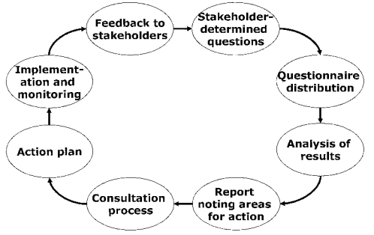

Fig. 1 - *Feedback collection process -* sourced from (Harvey, 2003 p.4)

Online questionnaires often have low completion rates. To try reach a larger number of students the National Student Survey (with a 60% participation rate target) will often resort to calling students. Other institutions will email students a few times and will leave the questionnaire open for a longer period (Douglas and Douglas, 2006). In an analysis of two Universities from Scotland Powney and Hall (1998) found that unless the surveys were mandatory and completed in class, student participation rates were low.

2.6 Solutions

In an analysis of the effects of student evaluations of teaching, Cohen (1980) reports higher ratings for lecturers who received midterm feedback. Although student learning did not improve between the midterm feedback group and the control group (who only used end of term feedback), students in the feedback group showed increased satisfaction towards the course. However, this is only true for those lecturers who received detailed feedback questionnaires from their students instead of ratings only. The reason for this could be that lecturers who received augmented feedback throughout the Semester had a foundation upon which to improve the course, while students became more positive towards these lecturers who tried to close the feedback loop. Figure 2 contains the mean ratings of the two groups based on aspects such as skill rating, difficulty of class, course structure and so on.

Although there are many challenges in implementing a feedback system, the main challenge is ensuring the feedback loop is closed and that students are aware of changes. Harvey (2003) recommends involving students in the feedback collection process (Figure 1) from the beginning, starting from asking students what to ask. To increase student participation Stowell et al. (2012) recommend encouraging students to complete the surveys through lecturers and emphasise the importance of their response in improving teaching. In 2015, the Department for Education conducted research on the usefulness of instant online student feedback (after class feedback questionnaires). The main findings reveal lecturers would be happy to implement it in their lectures as it is an easy method of observing their students views and an “opportunity to reflect more on how they teach” (Department for Education, 2015).

There has been a lot of research into how to construct evaluation questionnaires. McIver et al. (1980) suggest not to use single-item questions as they “tend to be less valid, less accurate, and less reliable than their multi-item equivalents”. Spooren et al. (2007) claim “measuring teaching skills by using a scaling technique is more reliable, more valid and hence more useful.”. By using appropriate instruments when collecting student feedback the analysis can provide meaningful insight and aid in improving teaching effectiveness.

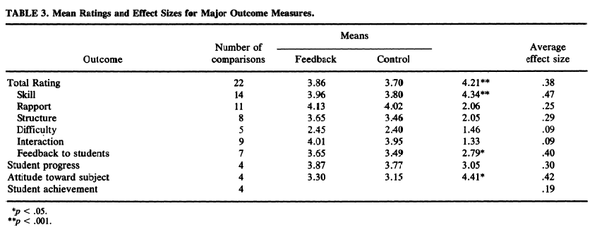

Fig. 2 - *Comparison results between feedback groups* - sourced from (Cohen, 1980 p.333)

2.7 Feedback Platforms

Universities use various platforms to collect student feedback out of which some are non-academic, for instance social media (Facebook, Twitter). Ratemyproffesors.com is a non-academic tool introduced in 1999 which has since attracted students worldwide to provide feedback on their lecturers. There are currently more than six million ratings for almost one million lectures (Felton et al., 2008). Despite its popularity there are quite a few issues with the feedback generated on this type of platform. An issue is that the main population of students participating are predominantly those with opposing opinions- students who are there to either praise their lecturer or leave negative comments (Felton et al., 2008). This could result in a biased aggregation of feedback which makes it less reliable. Due to the unreliability of the information Universities cannot use this data.

Figure 3 shows the effectiveness in response rate on various platforms in a study of 139 colleges in England. It is likely that this is similar in Higher Education institutions, although course representative feedback is commonly low and focus groups are not organised very often. Social media is used by some lecturers at the University of Southampton, however students seem to dislike the participation of lecturers in a private, informal space.

Stieger and Burger (2009) researched the use of formative feedback in-class with the aid of Twitter. Students had to create an anonymous account on Twitter and fill in a short questionnaire within two days after each lecture. To compare the results of formative feedback with summative feedback, the students had to fill in a paper based questionnaire and an online questionnaire at the end of the Semester. The results show no difference in the feedback generated between the paper-and-pencil and online summative feedback methods. Although there was a difference between summative and formative feedback, the researchers did not find improved ratings for the end of term questionnaires. Nonetheless, the data generated from the continuous formative feedback was useful. Twitter can be used as a feedback collection tool for this kind of feedback due to easy “handling of data” which makes the “the administrative efforts remain small” (Stieger and Burger, 2009).

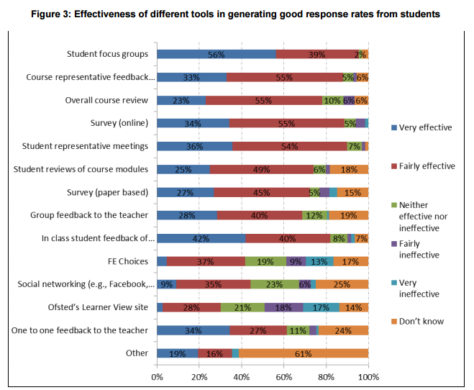

Fig. 3 – *Response rate on various platforms* – sourced from (Department for Education, 2015)

**3 Project Planning**

This section contains the planning methodologies used throughout the project development. By choosing appropriate planning methods the project can be then simplified into smaller tasks requiring less effort on overall. A Gantt chart and a risk assessment are also included as they contain the initial task breakdown in a timeline and how to deal with unexpected issues.

The scope of the project for the Second Semester was to develop a prototype tool to allow students to provide informal feedback to lecturers. I chose an iterative design methodology and later organised participatory design sessions.

3.1 Iterative Design

The methodology consists of following design, prototype, test, and refine cycles until reaching the final product. One of its benefits is the ability to include stakeholders throughout development and adapt the requirements according to their needs. This is important because there are a diverse number of opinions between students and lecturers alike. It is therefore crucial to consider the needs of these groups and not just rely on my own wants. This means the project design must be revisited and any issues with the initial design can be corrected on time. It also builds upon previous work which means every new iteration starts at the end of consistent testing. Figure 4 illustrates the lifecycle of the methodology and its components.

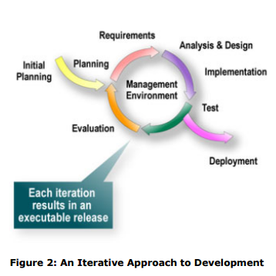

Fig. 4 - *Iterative Development* - sourced from (Kruchten, 2001 p.2)

3.2 Participatory Design

Participatory design consists of involving stakeholders throughout development by organising meetings where participants can express their needs. This means the design can be constructed based on their feedback, thereby ensuring all requirements are met. Benefits of the methodology include early recognition of design faults and a user-centred end tool.

The first iteration consisted of researching existing feedback methods and discussing with stakeholders. This was followed by coming up with a design based on the requirements I gathered. By proposing a design I was then able to present a prototype to the stakeholders and refine it according to their needs. The second iteration consisted in establishing the features of the tool and prioritising these based on importance. During this iteration, I implemented the skeleton of the application, consisting of simple client to server communication. The third iteration consisted of building the rest of the features and testing the application. I also organised another participatory design session to compare the outcome of the tool with the expectations of the stakeholders. The application was used in-class for two weeks and with the help of a focus group meaningful results were extracted. The project was built upon Agile thinking by breaking down the initial problem into subtasks which the prototype tried to solve.

3.3 Gantt Chart

There were a few issues which changed the initial Gantt chart and which I should have included as they changed the course of my plan. The main roadblock in the development stage was my inexperience as this was the first time I built a web application from scratch. Learning how to use an unfamiliar programming language and new frameworks has proven to be very time consuming. A reasonable solution to this would have been to spend some time during the first Semester learning how to use them.

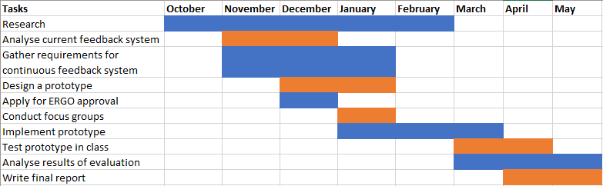

Fig. 5 - *Gantt Chart Version 1*

3.4 Risk Analysis

Figure 6 contains expected risks throughout the project, of which some were encountered. Although I initially planned to request a virtual machine from the University to host the application I decided to use cloud hosting instead. The main reason behind this was familiarity with the Heroku platform. In the first Semester, I had issues finding relevant literature, however the opposite became an issue when I found a very large number of journals on student feedback. The evaluation ran in-class for a period of two weeks (of which one was holiday) and almost no data was produced. Unfortunately, I was not able to manage this issue and in future would suggest releasing the application during a lecture (instead of by email) to get attention.

|  |  |  |  |  |
| --- | --- | --- | --- | --- |
| **Problem** | **Loss** | **Probability** | **Risk** | **Plan** |
| Scope is too large | 2 | 2 | 4 | I will choose to implement what I have discovered to be the crucial features. |
| Missed internal deadlines | 4 | 3 | 12 | Will use an Agile process to deal with any unexpected setbacks. |
| ERGO disapproval | 2 | 3 | 6 | Will resubmit the forms. This might mean organising the focus groups later in the Semester |
| Limited relevant literature | 4 | 1 | 4 | Will look in various sources. |
| Acquiring iSolutions VM is delayed | 2 | 3 | 6 | Will look for a Cloud Based service. |
| Not enough participants for focus groups | 4 | 3 | 12 | Will create flyers and I will also try to promote it through friends and acquaintances. |
| Prototype not finished on time | 5 | 2 | 10 | By following an Agile approach at each increment the prototype will be functional and only extraneous requirements will be left. |
| During testing students don’t use the system | 3 | 2 | 6 | By monitoring the participation on the system, I can intervene early and try to prevent this. |

Fig. 6 - *Risk Analysis*

**4 Design**

This section illustrates the approach on the design methodologies chosen, the design process, and the choices made. Relevant implementation choices and design artefacts have been produced to illustrate the adopted methodologies.

4.1 Iteration One

The first iteration consisted of identifying stakeholders, researching existing feedback tools, and meeting the primary stakeholders. Extra care was directed towards researching whether students and lecturers would be willing to use continuous feedback and how would this integrate with the current feedback system. The information gathered was then used to produce the initial design which seeks to improve the overall perception students have about feedback.

4.1.1 Stakeholder Analysis

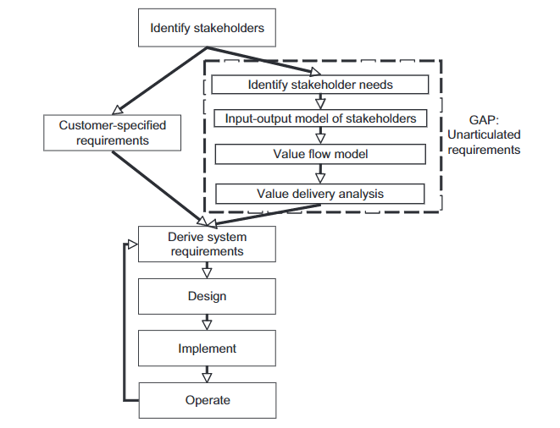Identifying stakeholders is essential to determine how they interact with a system and how could they impact the project. Bourne, Walker (2005) go as far to say a project’s success depends on successfully identifying key stakeholders and maximising their input. Throughout the paper, they emphasise the need to involve the stakeholders from the planning stages to understand their needs and help shape the project. Cameron et al. (2008) also suggest integrating stakeholder needs in the system requirements from the planning stages and through development. The primary stakeholders are the users who interact directly with the system and whose opinion was sought in the process. By using stakeholder input from the very beginning I was able to propose a design whose key features stayed the same through the whole project.

Fig. 7 - *Requirements analysis -* sourced from (Cameron et al., 2008 p. 325)

|  |  |  |
| --- | --- | --- |
| **Stakeholders** | **Type** | **Interaction** |
| ECS Students | Primary | Direct interaction with the system. Students will use the system to chat and provide anonymised course feedback to lecturers. |
| Lecturers | Primary | Receive student feedback through the system and comment on it. |
| Student representatives | Primary | Student representatives could have an administrator privilege. They will also provide feedback at SSLC meetings. |
| Director of Programmes | Secondary | Can see the student feedback and optionally can also comment on the actions taken by the University. |
| ERGO | Tertiary | Might change certain aspects of the student survey. Can also influence features of the system. |
| iSolutions | Tertiary  /Facilitating | Can influence the development of the website. Will probably host the system. |
| Project Designer | Facilitating/ Primary | Designs and develops a prototype of the system. |
| Project Supervisor | Facilitating/ Primary | Will influence the decisions made on the design of the system. |

Table 1 - *Stakeholder Analysis*

4.1.2 Personas

This section contains a written description of the various stakeholders identified and their needs. This has been produced as a result of discussing with students and lecturers on their interaction with the current feedback system and their expectations of such a system.

  
**Director of Programmes for Computer Science and Software** **Engineering: Elena Crowther**   
  
Elena is busy teaching and ensuring the rest of the courses are running smoothly. She must meet a few times a year with the student representatives (Staff Student Liaison Committees) to discuss any issues that might have occurred throughout the semester. At the end of the semester she also sorts the feedback forms the students have filled in for a course. She chooses the most relevant feedback and sends it to the module leader who writes an annual report evaluating the course. As a lecturer, herself she would like a system that allows her to get more constructive feedback from the students. She wants the system to be bidirectional so that she can respond to students too.

**Student Representative: Daniel Smith**

Daniel has been student representative for a few years now. He has an SSLC meeting soon and is trying to gather feedback from his colleagues. However, the response rate is low and he must offer feedback based on his own experience. He would like a feedback system which promotes interaction between students and lecturers. He has previously tried to encourage his colleagues to fill in the Semester module surveys but failed. He thinks that the feedback system should be more motivating.

**Lecturer: Paul Roberts**

Paul started teaching a few years ago and is keen about it. He wants feedback from his students so he can improve the courses he is teaching. The response rate the previous year has been very low and he would like to improve that. He thinks that the questions at the end of semester feedback forms should be reformulated to allow more constructive responses. He also thinks that students should be able to feed back on the spot rather than at the end of the semester. He likes the idea of a continuous feedback system and would like to try it out during his lectures. 

4.1.3 Analysis of feedback system

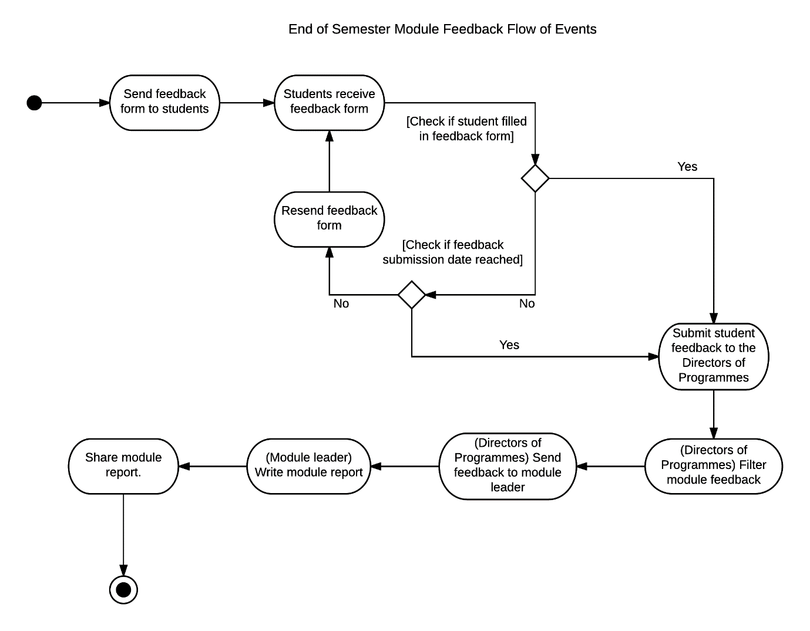In this section, an analysis of the feedback system provided by the ECS department is presented. As a student, most of the actions taken within the module survey process were already familiar to me, however I met lecturers and the Director of Programmes to produce an accurate representation of the process.

Fig. 8 - *Module Survey Activity Diagram*

The main feedback gathering method are the module questionnaires sent every Semester. An issue this method comes with is the timeline the module questionnaires are sent out. The feedback forms are forwarded to students just before Christmas break in the First Semester, and soon before the exam period for the Second Semester. These are the periods when students are busiest and will tend to forget filling in forms. Another immediate issue is what is known as “survey fatigue”. Long forms will demotivate most students, especially after providing minimal feedback in the form of ratings. By the end of the form when students are asked to provide comments they are often uninterested, and so will not provide the most constructive feedback.

Lecturers receive the feedback from students a month later after the module has ended. This has been mentioned as an issue by a few lecturers as it results in them being unable to communicate to previous students to discuss the results of the evaluation. Since 2015 the University has decided to share the module reports and the global ratings for each module. This has been implemented as a method of “closing the feedback loop” (Watson, 2003) which is intended to increase the student response rate. However, the response rate is still low and new actions for engaging students must be taken.

Students can also provide feedback through SSLCs (Student Staff Liaison Committees). Each Year has one or more Course Representatives who act as an intermediate between students and staff. They receive feedback from students which they then discuss with the staff Representatives. In return the Program Leaders respond with the actions undertaken to solve the issues. However, in the past student representatives would not receive much feedback from their classmates which makes this method less effective.

Lastly, informal feedback cannot be quantified but is an important communication method between students and lecturers. One of the issues identified here is the high student-staff ratio on most courses. This can result in lecturers being overwhelmed and students being uncomfortable to discuss with their lecturers.

4.1.4 Feedback system design proposal

I will design a web application which allows students to provide feedback and also communicate with their lecturers. This prototype seeks to create an informal environment where students will be able to provide constructive feedback. By having the system available throughout the Semester students can now provide immediate feedback after lectures. It also means lecturers will get valuable data on their teaching style to reflect on. And by allowing lecturers to reply to students’ feedback/questions the feedback loop will be successfully closed.

The project scope consists of creating a board for students where they can discuss a course. The students will be able to tag comments which are meant as feedback or questions, while the rest of the students will be able to rate them. If the rating of the comment reaches a certain threshold, it will be visible to the lecturer of the course. By using the collective intelligence of students, only useful feedback should be received by lecturers. Furthermore, each transaction will be anonymised in order to encourage students to provide truthful feedback.

4.1.5 Wireframes

In Figure 9 we can see that students will be able to choose from the modules they are enrolled on and a general board for their current course Year. Students can then post comments, which they can optionally mark as “Question” or “Feedback”, in which case the submission will be anonymous. Other students will then be able to endorse a post by clicking on the star next to it. Based on a threshold which will be calculated according to the number of students enrolled on a course, the feedback or question will be sent out to the course lecturer. The lecturers will be able to look through the modules they teach and reply to any sufficiently endorsed posts. Any replies will then be made visible to students.

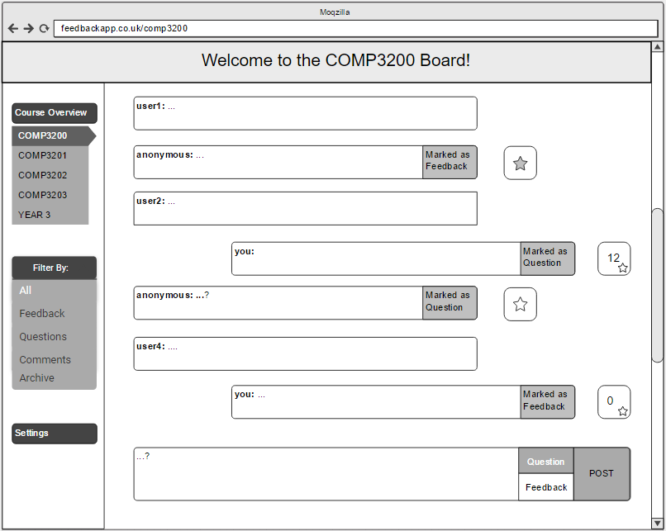 Fig. 9 *- Student view of the feedback board*

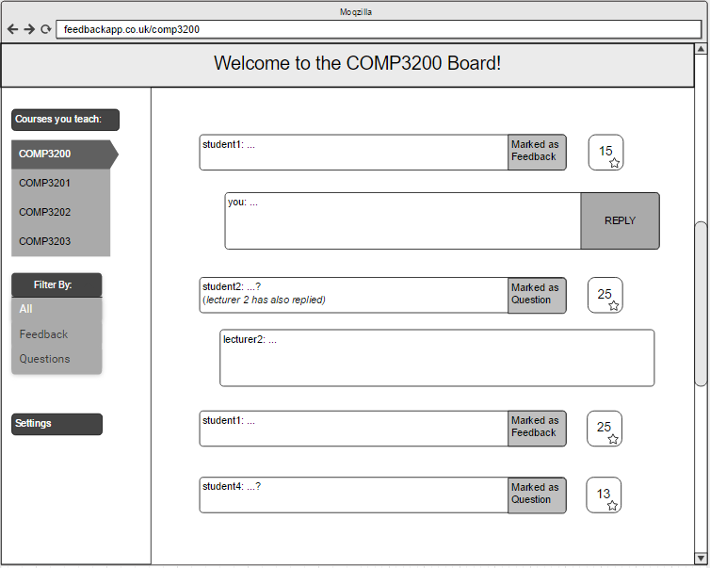Fig. 10 *- Lecturer view of the feedback board*

4.2 Iteration Two

The second iteration started in the Second Semester with participatory design sessions to learn more about what students and lecturers expect of a continuous feedback system.

Throughout the First Semester I talked to stakeholders to learn about their current experiences with the feedback system provided by the University. I also presented them with the idea of a continuous feedback system for which they suggested features. This has led me to implement a prototype in this iteration. My first decision was to organise a focus group where I could find out more about their experiences with feedback systems and what they expect of this tool. However, this was not appropriate as no discoveries can be made and the prototype had to be implemented at this stage. That is why I decided to organise participatory design sessions. With the participation of main stakeholders during the iterations of the implementation process I ensured the tool was built with appropriate features. By following a user centred approach, I was able to focus on both the functionality and the usability of the tool. The participants helped decide which features to include and how to design the website.

For the first participatory design session, I gathered a sample from the primary stakeholders of the project, in this case three students and a lecturer. After quickly introducing them the project I asked them to write down the features they would expect of a feedback system. I also gave them a few coloured sticky tapes which they used to prioritise the features by the MoSCoW method. At the end of this stage we discussed some of the features they wrote down and the issues and pros each one presented.   
  
I also handed out the wireframes created earlier this year of the prototype and approached each participant on its design and usability. The discussion which followed gave me the necessary insight to start the implementation phase. Although all feedback was useful the scope of the project is small due to limited time and therefore some features will have to be included in the Future Work section.

The following table contains some of the requirements specified by the participants ordered by importance.

|  |  |
| --- | --- |
| **MUST** | “System has to be unbiased. Potentially anonymous - users should not be afraid to provide feedback.” |
| **MUST** | “Ability to see previous feedback/discussion for younger students.” |
| **SHOULD** | “A way to prioritise feedback to easily identify things that need to be done.” |
| **SHOULD** | “Be able to search.” |
| **COULD** | “Measure of involvement? Metrics on lecturer/course approval/response time etc.” |

Table 2 - *MoSCoW Prioritised Features*

4.2.1 Product Backlog

The features were then compiled into user stories and used to construct the product backlog below.

|  |  |  |  |
| --- | --- | --- | --- |
| **As a ...** | **I want ...** | **so that ...** | **MoSCoW** |
| student | To be able to post comments | I can provide feedback | MUST |
| student | The post to be anonymised | Bias is removed | MUST |
| student | To rate my peers posts | Only relevant feedback goes through | MUST |
| lecturer | Students to be able to tag posts as questions | Relevant questions come through | MUST |
| lecturer | A level of safety against malicious comments | Students cannot disrespect me | MUST |
| lecturer | The posts to be filtered | I don’t have to go through all conversations | SHOULD |
| student/ lecturer | An email if anything new happens on the board | I don’t have to keep checking the website | SHOULD |
| student/ lecturer | The system to aggregate events | Only one email sent per week | SHOULD |
| student | My ratings to be hidden | Unconscious bias is eliminated | SHOULD |
| lecturer | To see the whole thread | I can understand the context | SHOULD |
| student | To see an overview of previous year’s posts | I can see how well did the course run | SHOULD |
| student | To be able to subscribe to certain threads | I get notified if anything new happens | COULD |
| lecturer | An analytics dashboard for a course | I can quickly see the trends of the board | COULD |

Table 3 - *Product Backlog*

4.3 Iteration Three

Figures 11 and 12 (Appendix G) show the final design of the login and forum page. During iteration three I finished the implementation of the tool. Due to time constraints, I have only managed to implement the user stories designated as “must” according to the MoSCoW prioritisation method. This was enough to return to the stakeholders in another participatory design session for testing. This time I have only gathered students so that they could try out the app before I released in-class. The main criticism was the lack of instruction on the different tags and how to reach the lecturer. I included information on both these topics in the email sent to participating students. Another issue mentioned was that the sidebar contained a button for filtering posts based on the tag which was not yet functional and which I removed afterwards.

During iteration three I had hoped to produce data from the in-class activity. Unfortunately, there was no meaningful activity on the website. This could have been due to the fact that it was released during holiday, that it was close to the deadline for various coursework, or due to lack of promotion. However, by organising the focus groups I was able to gather some data to construct a conclusion.

**5 Implementation**

The first step in the implementation process was creating a visualisation of the student and lecturer actions. This was useful as I could then see the key features and work on the next task of deciding which technology to use.

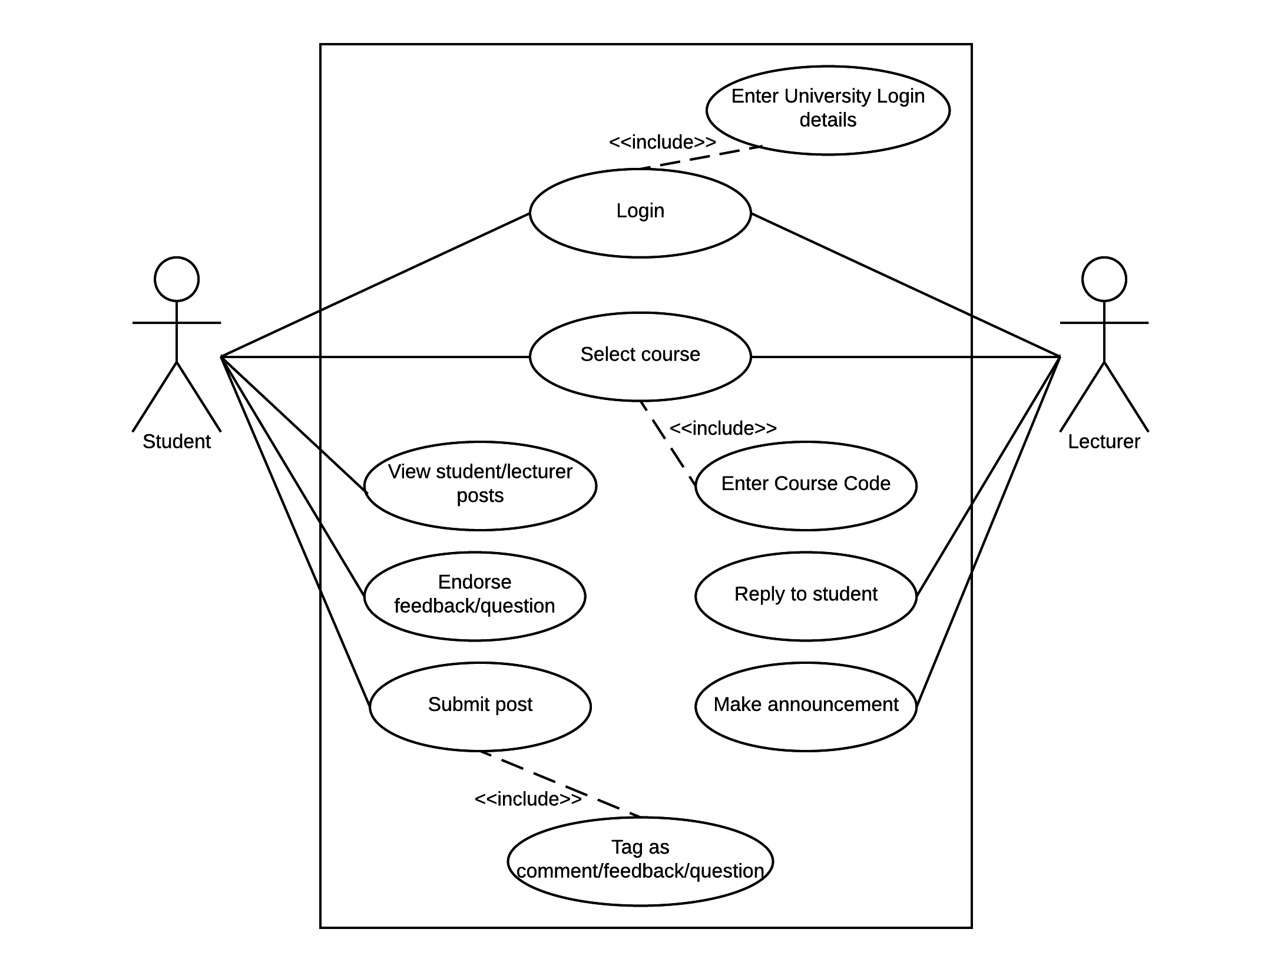Both students and lecturers will have to login first with their University details. Although students will be assigned a permanent anonymous nickname, the system must ensure the student is enrolled on the course and also identify the students in case of misconduct. This could be easily implemented through the open source Shibboleth system which is an intermediate login system used worldwide to connect students to applications outside the University. At the moment, the prototype uses a combination of username and password details chosen by the user with no restrictions other than length. This was implemented for the purpose of identifying returning users.

Fig. 13 - *Student and lecturer interaction with the system*

Students and lecturers will also have to select the course they are enrolled on, or teaching, by entering a course code or by selecting it from a menu. Currently there is only one course as the application does not support multiple courses. The rest of the features detailed in Figure 13 are all implemented. Students can view, post, and vote comments which the lecturers can also see if they reach a threshold. In the prototype the threshold is currently set at five votes for testing purposes.

Due to previous familiarity with web development I decided for the prototype to be implemented as a web application. The decision for each of the technologies chosen was based on familiarity and suitability to the project.

|  |  |  |
| --- | --- | --- |
| **Name** | **Features** | **Suitability** |
| Heroku | Cloud Platform | Used previously in another course. Easy to use and extensive documentation. Can upload to cloud directly from version control. |
| Socket.io | Node.js framework for Client-Server Communication | Easy to use with good documentation. Still widely used; alternative is WebSockets which seems more complex and therefore unsuitable for this project. |
| Semantic UI | User interface development framework | Provides themes and other features for quicker UI development. Looks great with minimal work and integrates well with everything else. |
| Express.js | Node.js web framework | Offers easy routing methods. |
| Git | Version Control System | Backup source code and integration with Heroku. Widely supported and extensive previous experience. |
| PostgreSQL | Relational database system | Integrated in the free service Heroku offers. Similar to other SQL systems I have previously used. Features JSON data type which allowed me to store message objects as JSON instead of separating into components (timestamp, author, tag etc.) |
| Passport.js | Authentication middleware | Can be easily integrated with Express.js. Choice of social networks (Twitter, Facebook) or other platforms for user to login from. Did not use in the end because of safety and security reasons. |

Table 4 - *Technologies used*

Hosting the project on Heroku meant I was able to quickly set it up. Another option was to use a VM from the University, however as I don’t have any experience with it, it seemed risky. One of the drawbacks of Heroku was clearing the Postgres tables containing the user details and messages as this was only possible by resetting the database manually and therefore having to recreate the tables each time. Another issue with using the free version provided by Heroku is that when the app is not used for 30 minutes, the dyno sleeps, and can take a while to load back up. The user interface took some time to implement as it was the first time I used Semantic UI, however the features offered by Semantic UI outweighed the time required to become familiar with the framework.



Fig. 14 - *Semantic UI*

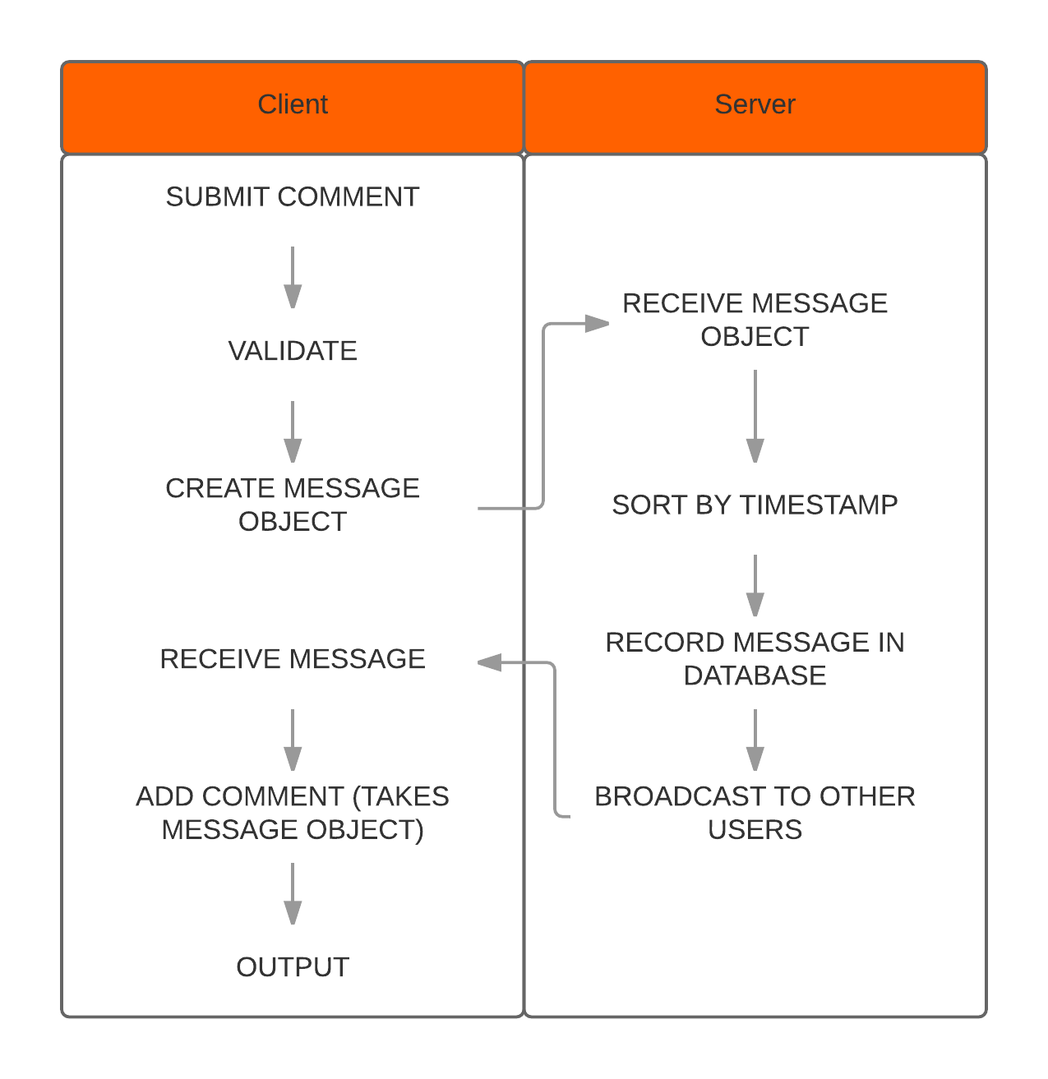Figure 14 contains code written with Semantic UI and shows how the classes of the html elements can be combined to quickly create a customised page element. There was an issue with integrating Semantic UI on Heroku. This was caused by using node.js to compile the Semantic UI code, however this was easily solved by using the framework’s CDN.

Fig. 15 – *Messaging Illustration*

One of the challenges encountered was implementing the client to server communication. Each time a user submits a comment it must be broadcast to the rest of the users and inserted in the database. This means sorting through the list of messages according to the timestamp of the message and only then inserting it on the board. Figure 15 contains a simple diagram I created to illustrate the process behind messaging. By using insertion sort the array of messages is sorted by timestamp and new messages are inserted at the end of it.

**6 Testing**

Most of the testing was done throughout the implementation stage to ensure the requirements were met. With the use of scenario testing the test cases were built from the functional requirements to ensure the system behaved correctly. Due to the limited scope of the project, there were not many features to be tested from the start. Extensive testing was performed on the client-server communication to ensure the messages were inserted correctly on the page and broadcasted to the rest of the users. It is important to set up the messaging correctly as all other requirements depend on it. The testing was done iteratively to ensure the basic requirements ran correctly first and then build on top of that.

6.1 Black-Box Testing vs White-Box Testing

Black-box testing, also known as functional testing, is a method of ensuring a system is behaving according to expectations (Nidhra, 2012). One of its advantages is that the tester only needs to know the expected output of the application and not the implementation of the software. On the other hand, white-box testing requires the tester to understand the internal behaviour of the application to examine the system and prevent failures. The main advantage of black-box testing is that it exposes any unanticipated issues with the requirements (Nidhra, 2012).

While designing the product I wrote various scenarios for the possible users of the system. This allowed me to then identify the requirements to test later on during development. A reason behind using scenario testing is to “learn the product” and “connect testing to documented requirements” (Kaner, 2003). Writing scenarios meant exploring how would students and lecturers use the system and therefore focusing on their needs and the usability of the system. Table 5 contains the test cases and the number of tests for each one. The actual scenarios can be found in Appendix C. Some of the tests assessed more than one feature, for instance while testing comment insertion, both post tagging and voting was assessed.

User testing was not specifically implemented because the application was set to be evaluated both in-class and during the qualitative research (participatory design sessions and evaluation focus groups).

6.2 Scenario Testing

|  |  |  |  |
| --- | --- | --- | --- |
| Test Component | Number of Tests | Pass | Fail |
| Comment Insertion on Forum Page | 4 | 2 | 2 |
| Comment Insertion in Database | 1 | 1 | 0 |
| Post tagging | 3 | 3 | 0 |
| Voting posts | 2 | 2 | 0 |
| Forward comment to lecturer | 2 | 2 | 0 |
| Login/Logout | 2 | 2 | 0 |
| Message from lecturer | 2 | 1 | 1 |

Table 5 - *Testing components*

One of the issues found during testing was the sorting of the comments on the board. For instance, user A posts for the first time and the message is inserted, user B comments too, however B’s comment is inserted before A’s comment. The issue behind this was the construction of the message timestamp. Each message is assigned a timestamp containing the time of the submission as shown in Figure 16. However, the value of the timestamp was not multiplied by 100 when adding the seconds causing the errors.

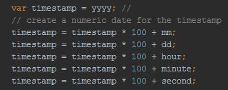

Fig. 16 – *Message timestamp*

**7 Evaluation**

The following section contains the evaluation methodology and results. The study was accepted by ERGO with Ethics Number 24680.

7.1 Goals

The aim of the project was to research and propose a continuous feedback method to aid the current feedback system. To verify the effectiveness of the design proposed the application was run for a period of two weeks in a third-year class. Towards the end a focus group was organised to evaluate usability and whether the proposed method is a viable feedback tool.

The purpose of the application is to create an environment where students feel comfortable providing feedback. The environment should be informal enough so that students can give truthful feedback, but also formal so that they will not feel the lecturer is invading their personal space by being an observer. Voting was added to reduce the number of messages the lecturer receives, however a few lecturers preferred being sent all messages sorted by number of votes. Most students preferred the voting of a post to be hidden because they agreed it could influence their opinion and it could discourage others from posting. The evaluation aims to find out how do these features influence the system and how could it be improved.

7.2 Approach

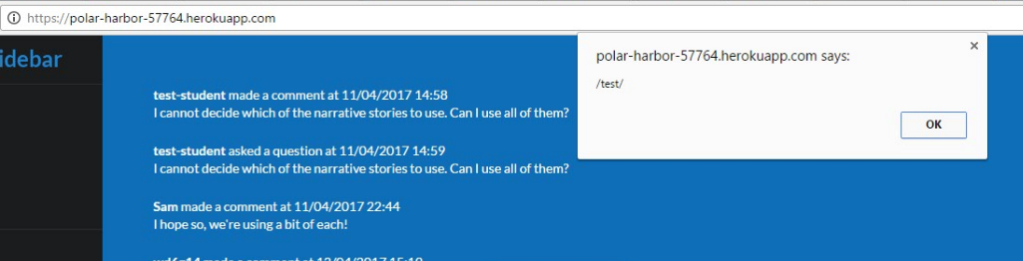The class chosen to test with had a coursework set and some activity was expected during the holiday due to this. The lecturer sent out an email (is included in Appendix E) to all students. When the website was deployed, there were a few security issues which the students tried to exploit. The students performed benign html injection and later on malicious cross-site scripting. The later one caused the forum page to crash, and required the Heroku database to be reset in order to correct.

Fig.17 – *Malicious XSS Injection*

Following this incident, I decided to fix these issues by matching the comment input with a regular expression to find any html tags and replace it with a plain text warning. The website was back up in a few minutes and no more malicious attempts were made.

Reaching students to participate on a new system is often very difficult and in this case no more activity occurred. To learn more about the application I decided to continue the qualitative research and organise a focus group. Students from the course were invited and after presenting the system they had the opportunity to use it for a few minutes. The discussion was recorded and later transcribed.

7.3 Results

**Thematic Analysis**

According to Boyatzis (1998) thematic analysis consists of identifying and analysing patterns within data. Saldana (2009) defines themes as the outcome of “coding, categorization, and analytic reflection”.

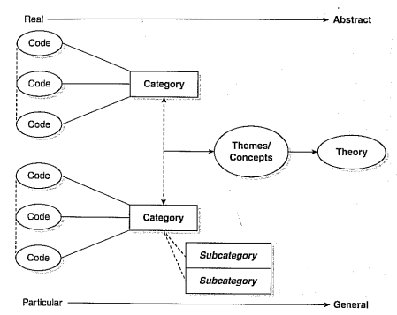

Fig. 18 – *Thematic Analysis* – sourced from (Saldana, 2009)

Categorising the data with the use of coding enables you to determine the themes of the research and construct a conclusion. I repeatedly coded the transcript until no new themes emerged. Table 6 contains the categorisation of data from the discussion with the focus group. Each theme was deconstructed into subthemes which contain a representative quote and the frequency they appear in the transcript.

|  |  |  |  |  |
| --- | --- | --- | --- | --- |
| **Theme** | **Subtheme** | **Freq.** | **Keywords** | **Quote** |
| Participation | Engagement | Medium | Mandatory, optional, threshold, low participation, in-class, momentum | “... if the participation is low and doesn’t reach a threshold they won’t care about your feedback. If it was mandatory instead of optional and everybody submitted their feedback maybe it would count.” |
| Incentives | High | Time of action, relevance to student, acknowledgement, lecturer approachability, friend activity | “... this app would address that the module feedback doesn’t change anything for your experience. You’re doing something good for the following years, this has the chance to change to get the feedback into the module while the module is still running.” |
| Social Issues | High | Public, anonymity, friend activity, first year students, timidity, stigma, experience, confidence | “There’s a stigma there really, they might think their questions are too basic because they don’t have any programming experience.” |
| Course Satisfaction | Low | Bias, bad module, unfair criticism/praise, passionate | “... there isn’t really an incentive to provide positive feedback. It’s the kind of place where if something is wrong or people need help they will go and say something.” |
| Feedback methodology | Question Type | Low | Time consuming, response rate, ease of response | “I think a system like this would encourage the middle segment of the student population to vote. because you have the module questionnaires where you have to spend like half an hour and you’ll only get the people who really, really like or really, really hate it.” |
| Interpretation | Low | Aggregation, wording | “Everybody submits their feedback however it’s not aggregated. Wording can be different and the way people write is different from others meaning that the same issue can be worded differently and not recognised.” |
| User Behaviour | Student | Medium | Passive voting, active commenting, abuse, misuse, trust, wisdom of the crowd | “...the people who are not as passionate will only have to click a button which is much more passive and much easier. So probably more likely to see what the key issues are…” |
| Lecturer | Low | Trust, abuse, responsiveness | “At some point, you need to identify with the lecturer. Anonymity is good till a point, but at some point trust must be there from both sides and they’ll have to talk to each other at some point.” |
| Moderator | Medium | Course representatives, volunteers, middle layer moderation | “You could have maybe somebody else from the University, such as the course reps, moderating it instead. As long as they couldn’t just find out who you are just because they wanted to and abuse the system.” |
| Usability | Security and Safety | High | Anonymity, traceability, accountability, terms of use, flagging, archiving | “... a statement people accept or that comes when they’re posting something which would be along the lines “By using this service you agree not to post inappropriate content…”. Need to remind students this isn’t just a forum and you will be held accountable...” |
| Information Categorisation | Low | Filtering, message boards/rooms, priority | “Instead of having a comp3 room you could have different rooms within a forum. They could be on different things.” |
| Presentation | Medium | Unfamiliar technology, minimise comment threads, anonymous questions, polls, archiving | “Having a poll system where somebody could post a question, like with A, B, C, D like they do on Facebook groups.” |

Table 6 - *Thematic Analysis*

The most common topics of the discussion were incentivising users to participate in the system, the social issues which emerge when using the application, and the safety and security of the users. They agreed the main reason behind using the app is the opportunity to improve their experience within the Semester. However, to engage with the system students said they would need friends participating and in-class demonstrations. Anonymity was agreed to be essential to provide truthful feedback and to remove the worries of students (such as stigma or asking “stupid” questions). Still, they identified the possibility of misusing the system if students were completely anonymous.

A solution which emerged from the participatory design sessions is to assign a nickname to users but link it with their University details. During the focus group session, I suggested this idea which they felt is appropriate. On top of this they suggested introducing moderators who could ensure the messages sent to the lecturer are appropriate and also report students in case of misconduct (such as breaching academic integrity standards). Another suggestion was to introduce a terms of use statement where students agree to use the system responsibly. This would be an effective approach to remind students this is not just a forum and its function is to provide an environment for safe feedback. It would also remind them their messages will be archived for future students and therefore they should use the system sensibly.

Course satisfaction is another subtheme which students agreed influences feedback so much that they would only fill in the module questionnaires when a course was exceptionally great or to complain. One of the advantages of my solution is that it allows the students who are less willing to participate actively to raise critical issues without putting much effort in. A concrete example of feedback from a student was one of the lecturers who could not answer their in-class questions due to poor hearing. The student said nobody would approach the lecturer on this and thinks that through the application such an issue could be raised in a sensible manner. Less frequent sub-themes were the features of the system such as adding rooms within the forum, filtering and sorting posts, and adding polls.

**8 Reflection**

The project has evolved well, although there were some challenges in planning, the implementation of the application, and the evaluation. Due to these challenges the application was released late and the in-class activity did not produce meaningful results. However, by conducting focus groups important questions about the outcome of the project were answered.

One of the key issues of the planning was not researching the timetable of the project. I included May as a working month although the deadline was on the first of May. Another issue is the testing of the prototype in-class which should have run in March and April but only ran in April. The issue was the project planning which was optimistic as I intended the tool to be ready by the end of February and it was late by two weeks. Running the application in-class for only April meant there was almost no activity as there was a four-week holiday. It would have been nice to release the website in a few classes for a longer period to gather more conclusive results.

One of the challenges which resulted in releasing the application late was unfamiliarity with some of the software used. This could have been solved by watching tutorials and practicing before actually starting to work on the project. I also spent a large amount of time designing the tool instead of implementing the backend of the app first and building upon that. If I were to redo the development I would use tutorials beforehand to build the confidence necessary for working on a larger project. Although the prioritisation of the features was done well, the features should have been broken down further into smaller tasks and only then organised by importance.

The revised Gantt Chart can be found in the Appendix B and contains the differences in time coloured in grey between the planned timetable and the actual one. I underestimated the time required for research because of the diverse and contradictory sources on feedback in Higher Education which called for further investigation. While researching I found a very large number of papers on student feedback which I had to reduce to those most relevant to this project.

Main input on designing a continuous feedback tool was received from lecturers and students. However, more research should have been directed towards the administrative issues continuous feedback comes with. If a lot of data is generated by this tool it will need to be stored and managed by an entity. It may be that Universities are not happy storing student data offsite and would prefer an on-site solution.

**9 Conclusion and Future Work**

The results of the research indicate continuous feedback is desired by students and lecturers alike. It also shows they are willing to use the system with some modification. The application I built as proof of concept can be improved by adding many more desired features which were mentioned in the focus groups. Additional research on feedback collection methods, student behaviour, and usability will improve the system even further. The system could potentially be integrated with the rest of the feedback methods or even absorb them. By introducing this application in a class I think communication between students and lecturers could improve and still be manageable for the lecturer.

Most of the future work comes from the discussion with the participants from the evaluation focus groups and the participatory design sessions. The key features revolve around making improvements to the tool rather than changes. Most of the suggestions were related to system notifications both for students and lecturers. In the next few paragraphs a few of the most essential features are presented.

**Aggregate activity**

While discussing about the features of a feedback system one of the concerns was having to check the board daily. A possible suggestion was sending out an email if there is any activity on the day. However, participants said receiving daily emails would quickly become irritating. A solution to that is to aggregate the activity on the board and send out a weekly email. The email would include information on the number of messages posted -which will be sorted by the type of tag, lecturer announcements for the students, and the messages which reached the threshold when sent out to the lecturer.

**Dashboard**

The previous features are closely tied to the dashboard page. Lecturers suggested as they cannot see any student posts they would like to be able to access a page which contains information on the amount and type of activity in the forum. An email cannot contain much information and also cannot present it in a very user friendly manner which brings us to the dashboard. Every course will be linked to a page which collates information of the forum activity. Both lecturers and students will be able to get an overview of the number of students enrolled, number of posts for every day/week/month and other useful information.

**Course archive**

This feature was suggested by most students, that is they would like to be able to access the activity produced from previous years. This means the discussions produced by a class would have to be locked to disallow participation. It also raises the question of how many years to archive as this could be a large amount of data. However, as some of the improvements raised throughout a Semester cannot be implemented quickly enough for the current student cohort this would allow lecturers the time and the means to show the next generation of students the changes made. Students also stated they would probably be influenced on their module choice by the activity produced, type of feedback and the course atmosphere. This could be detrimental to a course where there was no activity as no opinion can be formed and it is something to be considered in the future.

**Subscription**

Students added they do not want to be restricted to search through the board to find if a post was replied to. The addition of a subscribe feature to the application could be the solution. Students will be able to choose to subscribe to a specific comment and be emailed if the comment is replied to. This means students will not have to go through all messages to find the reply and will instead be able to access a subscription page. The end of the week email could also be tailored based on the user’s subscriptions. Another possibility is to assign two white coloured circles to the course tab which will be coloured it based on what happened since you last logged in. The first circle will be coloured red if a post you subscribed to had a reply, while the second one will be coloured if the lecturer made an announcement or replied to another post in the meanwhile.

**Comment threads**

A question which emerged since the start of the project is how to design the flow of the comments. In most forum applications users are able to reply to posts and there are situations where students will need this. Furthermore, as lecturers might need to see the context of the messages they received the posts need to be somehow linked to each other. A possible solution is to add a reply feature to all posts; however comments are hidden from lecturers and the message flow might not make any sense if sent without comments. Another suggestion is to only allow replies for messages tagged as feedback or question. These message types are the only ones which might require a reply and the only ones which can be sent to the lecturer. Therefore, if a post reaches the lecturer any comments under it will also be sent out. Users will also be able to collapse or expand a comment thread.

**Filtering comments**

When looking up for a specific message users should be able to search for it. A practical feature would be to add a filtering button. The filtering could be done on various aspects, such as tags, comment, feedback or question, date and author. Additionally, users will be able to search through their subscription list.

**10** **References**

Cohen, Peter A (1980). *Effectiveness of Student-Rating Feedback For Improving College Instruction: A Meta-Analysis Of Findings*. Research in Higher Education 13.4: 321-341.

Leckey, Janet, and Neville Neill (2001). *Quantifying Quality: The Importance of Student Feedback.* Quality in Higher Education 7.1: 19-32

Laurillard, D. (1993). *Rethinking University Teaching: A Framework for the Effective Use of Educational Technology*. London: Routledge.

Marsh, H. (2007). *Students’ Evaluations of University Teaching: Dimensionality, Reliability, Validity, Potential Biases and Usefulness*. [online] Available at: eva.um.ac.ir/images/43/Maghale/18.pdf

Sambell, K. (2011). *Rethinking feedback in higher education: an assessment for learning perspective*. 1st ed. Bristol: ESCalate.

McIver, J. P. & Carmines, E. G. (1981). *Unidimensional scaling*. Sage University Paper series on Quantitative Application

Felton, James et al. (2007). *Attractiveness, Easiness, And Other Issues: Student Evaluations Of Professors On Ratemyprofessors.Com*. SSRN Electronic Journal 33.1: 45-61.

Stieger, Stefan, and Christoph Burger (2009). *Let's Go Formative: Continuous Student Ratings With Web 2.0 Application Twitter*. CyberPsychology & Behavior 13.2: 163-167

*Instant student feedback on teacher practices*. (2015). 1st ed. Department for Education. [online] Available at: www.gov.uk/government/uploads/system/uploads/attachment_data/file/435792/RR475_Instant_student_feedback_on_teacher_practices_report.pdf

Jeffrey R. Stowell, William E. Addison & Jennifer L. Smith (2012). *Comparison  
of online and classroom-based student evaluations of instruction, Assessment & Evaluation in Higher Education*. 37:4, 465-473, DOI: 10.1080/02602938.2010.545869

Hoffman, K.M. (2003). *Online course evaluation and reporting in higher education*. In New directions for teaching & learning*, 96*, 25-29.

Ballantyne, C. 2003. *Online evaluations of teaching: An examination of current practice and considerations for the future*. In New directions for teaching & learning, ed. T.D. Johnson and D.L. Sorenson, vol. 96, 103–12

Watson, S. (2003) *Closing the feedback loop: Ensuring effective action from student feedback*, Tertiary Education and Management. [online] Available at: dx.doi.org/10.1080/13583883.2003.9967099

Williams, Ruth and Brennan, John (2004). *Collecting and using student feedback Date: A guide to good practice.* Higher Education Academy, York, UK.

*Responding to feedback from students. Guidance about providing information for students*. (2016) [online] Available at: www.qaa.ac.uk/en/Publications/Documents/responding-to-feedback.pdf

Frey, Peter W. (1978). *A Two-Dimensional Analysis of Student Ratings of Instruction*. Research in Higher Education 9.1: 69-91

Rowley, J. (1995). *Student feedback: a shaky foundation for quality assurance*. Innovation and Learning in Education Vol. 1 No. 3: 14-20.

Harvey, Lee (2003). *Student Feedback*. Quality in Higher Education 9.1: 3-20.

Powney, J. & Hall S. (1998). *Closing the Loop: The impact of student feedback on students’ subsequent learning*. Edinburgh, Scottish Council for Research in Education.

M. Barker, M Pinard (2014). *Closing the feedback loop? Iterative feedback between tutor and student in coursework assessments.* Assessment & Evaluation in Higher Education Vol. 39, Iss. 8.

Douglas, J. and Douglas, A. *Evaluating teaching quality.* Quality in Higher Education (2006), Vol. 12 No. 1: 3-12.   
  
Mark Huxham, Phyllis Laybourn, Sandra Cairncross, Morag Gray, Norrie

Brown, Judy Goldfinch & Shirley Earl (2008). *Collecting student feedback: a comparison of*

*questionnaire and other methods*. Assessment & Evaluation in Higher Education, 33:6, 675-686.

P. Spooren, D. Mortelmans & J. Denekens (2007). *Student evaluation of teaching quality in higher education: development of an instrument based on 10 Likert‐scales*. Assessment & Evaluation in Higher Education, 32:6, 667-679, DOI: 10.1080/02602930601117191

Richard E. Boyatzis (1998). *Transforming Qualitative Information: Thematic Analysis and Code Development*. SAGE Publications

Saldana, Johnny (2009). *The Coding Manual for Qualitative Researchers*. London. Sage, ch.1.

Nidhra, Srinivas (2012). *Black Box and White Box Testing Techniques - A Literature Review*. International Journal of Embedded Systems and Applications 2.2: 29-50.

Cameron, Bruce G. et al. (2008). *Value Flow Mapping: Using Networks to Inform Stakeholder Analysis*. Acta Astronautica 62.4-5: 324-333.

Lynda Bourne, Derek H.T. Walker, (2005). *Visualising and mapping stakeholder influence.* Management Decision, Vol. 43 Issue: 5, pp.649-660, doi: 10.1108/00251740510597680

Kruchten, Philippe (2001). *From Waterfall to Iterative Development -- A Challenging Transition for Project Managers*. Rational Software, p. 2. [online] Available at: www.researchgate.net/publication/237518074_From_Waterfall_to_Iterative_Development_--_A_Challenging_Transition_for_Project_Managers

Kaner, C. (2003). *An introduction to scenario testing*. Lecture Notes, Center for Software Testing Education and Research, Florida Institute of Technology. [online] Available at: www.researchgate.net/profile/Cem_Kaner/publication/264886163_Scenario_Testing/links/55528cd208ae6943a86d74e4.pdf

**11 Appendices**

A. University of Southampton Module Survey Questions

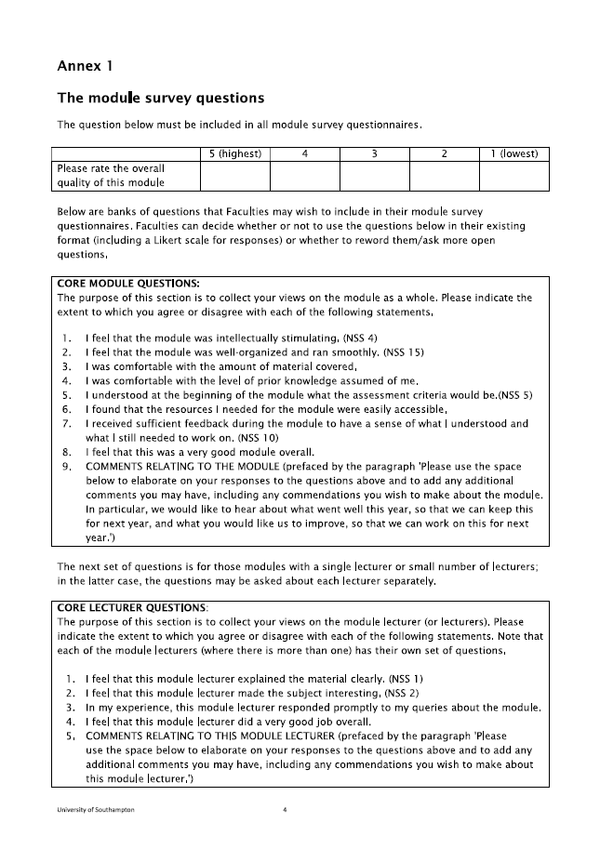

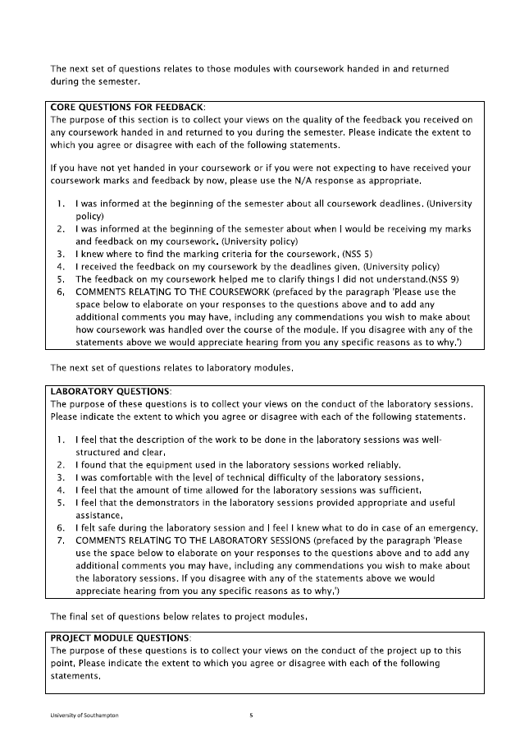

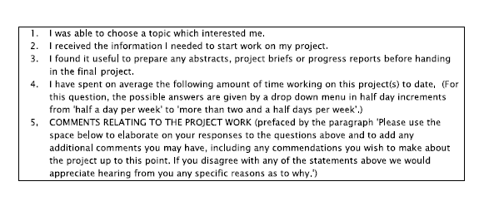

B. Updated Gantt Chart

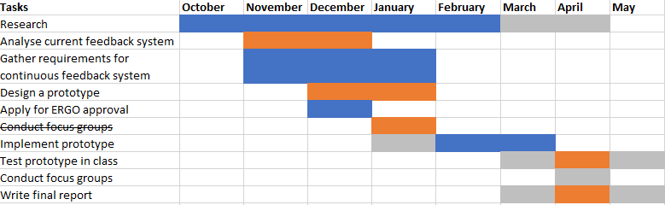

C. Testing scenarios

|  |  |  |  |
| --- | --- | --- | --- |
| Test Component | Number of Tests | Pass | Fail |
| Comment Insertion on Forum Page | 4 | 2 | 2 |
| Comment Insertion in Database | 1 | 1 | 0 |
| Post tagging | 3 | 3 | 0 |
| Voting posts | 2 | 2 | 0 |
| Forward comment to lecturer | 2 | 2 | 0 |
| Login/Logout | 2 | 2 | 0 |
| Message from lecturer | 2 | 1 | 1 |

|  |
| --- |
| **Test Case One - Messaging** |
| The lecturer has been asked to use a new feedback system and he introduced it today during a lecture. He also sent an email to his students containing information on how to use the system. To encourage students to use the application he made two posts on the app, one asking students for feedback on the difficulty of the lectures and another one on the quality of the classroom. |
| **Scenario 1:** |
| Lecturer logs in the system and posts two comments. |
| **Expectation:** |
| Comment is made visible to all students. The messages posted are inserted in the message table. |
| **Result:** |
| Partial Fail. The second message is inserted before the first one. |
| **Solution:** |
| After checking if insertion sorting was implemented correctly I identified the error in the construction of the message timestamp such that the timestamp value of the second message was lower than the value of the first message. By fixing the timestamp and reposting the comments, the order of the messages was now correct. |

|  |
| --- |
| **Scenario 2:** |
| Heather saw the email and she decides to give the application a go. She logs in and she submits a message which she tags as feedback. |
| **Expectation:** |
| Heather can see the two messages the lecturer posted. The message she posted is not yet visible to the lecturer. Her login details and the message she posted are inserted in the corresponding tables in the database. The user details are inserted in the user table. |
| **Result:** |
| Pass. |

|  |
| --- |
| **Scenario 3:** |
| Jane also logs in to ask a question. She sees Heather’s post and she decides to upvote it. |
| **Expectation:** |
| Jane’s message is inserted and Heather’s post increases by one vote. |
| **Result:** |
| Pass. |

|  |
| --- |
| **Scenario 4:** |
| Josh logs in and sees his classmates’ posts. He decides to upvote Heather’s message but he changes his mind almost immediately and removes his vote. |
| **Expectation:** |
| No changes. |
| **Result:** |
| Fail. The post Josh upvoted is still at rating 2. |
| **Solution:** |
| The issue behind this error is that the user was not registered correctly when voting, resulting in not being able to remove the vote. |

|  |
| --- |
| **Scenario 5:** |
| A few more students login and start chatting, they also upvote their classmates previous posts. |
| **Expectation:** |
| Messages posted as comment cannot be rated. Jane’s message reached the threshold which is currently set at 5 and is made visible to the lecturer |
| **Result:** |
| Pass. The lecturer can now see Jane’s question. |

|  |
| --- |
| **Scenario 6:** |
| Ben has recently finished a Cyber Security course and is trying out a few simple tricks to break the webpage. He inserts html code in the comment box such as input fields. |
| **Expectation:** |
| The html will be printed as plain text. |
| **Result:** |
| Input field is inserted in the comment. |
| **Solution:** |
| This was implemented after the malicious attacks during evaluation. The solution is to match the text from the input fields and check if it’s html code. If yes then replace this so that the result will print only text. |

D. Source code

The source code for the application was included in the submission files and can be found archived under the Dissertation Project folder.

E. Participation Email

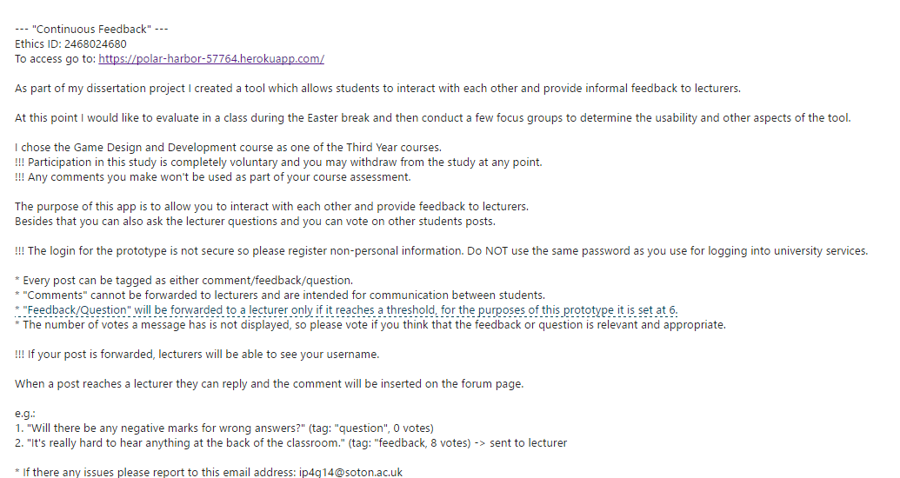

F. Ergo Application

**FPSE Ethics Committee  
FPSE EC Application Form Ver 6.6e**

Refer to the Instructions and to the Guide documents for a glossary of the key phrases in **bold** and for an explanation of the information required in each section. The *Templates* document provides some text that may be helpful in preparing some of the required appendices.

Replace the highlighted text with the appropriate information.

Note that the size of the text entry boxes provided on this form does **not** indicate the expected amount of information; instead, refer to the *Instructions* and to the *Guide* documents in providing the complete information required in each section. Do **not** duplicate information from one text box to another. Do not otherwise edit this form.

|  |  |  |
| --- | --- | --- |
| Reference number: **ERGO/**FPSE**/** 24680 | Submission version: 3 | Date: 2017-03-20 |
| Name of **investigator**(s): Iovana Pavlovici | | |
| Name of supervisor(s) (if student **investigator**(s)): David Millard | | |
| Title of study: Continuous Student Feedback | | |
| Expected study start date:  2017-03-23 | Expected study end date:  2017-05-01 | |
| ***Note*** that the dates requested on the “IRGA” form refer to the start and end of *data collection*. These are *not* the same as the start and end dates of the study, above, for which approval is sought. (A study may be considered to end when its final report is submitted.)  ***Note*** that ethics approval must be obtained before the expected study start date as given above; retrospective approval cannot be given.  ***Note*** that failure to follow the University’s policy on Ethics may lead to disciplinary action concerning Misconduct or a breach of Academic Integrity.  By submitting this application, the investigator(s) undertake to:  • Conduct the study in accordance with University policies governing: **Ethics** (http://www.southampton.ac.uk/ris/policies/ethics.html); **Data management** (http://www.southampton.ac.uk/library/research/researchdata/); **Health and Safety** (http://www.southampton.ac.uk/healthandsafety); **Academic Integrity** (http://www.calendar.soton.ac.uk/sectionIV/academic-integrity-statement.html.  • Ensure the study Reference number ERGO/FPSE/xxxx is prominently displayed on all advertising and study materials, and is reported on all media and in all publications;  • Conduct the study in accordance with the information provided in the application, its appendices, and any other documents submitted;  • Submit the study for re-review (as an amendment through ERGO) or seek FPSE EC advice if any changes, circumstances, or outcomes materially affect the study or the information given;  • Promptly advise an appropriate authority (Research Governance Office) of any adverse study outcomes (via an adverse event notification through ERGO);  • Submit an end-of-study form if required to do so. | | |
|  | | |

Refer to the Instructions and Guide documents when completing this form and the Templates document when preparing the required appendices.

**Pre-study**

Characterise the proposed **participants**

The proposed participants are students from Computer Science and Software Engineering courses. The students will be from different years of study and could potentially be friends.

Describe how **participants** will be approached

For each Computer Science Year, there is a group on Facebook. I will approach the participants by creating a post about the study. The students will then be able to message me to sign-up for one of the focus group meetings.

Describe how inclusion and/or exclusion criteria will be applied (if any)

The only inclusion criterion is for the participants to be Computer Science students in their First Year of study, Second or Third Year of study. Only the target participants will be invited due to the approach method. No other inclusion or exclusion criteria will be applied.

Describe how **participants** will decide whether to take part

The participants will be able to message me if they want to take part in the focus groups. If they are available on the dates specified, they can participate in the study. Participants will also be shown the consent information at the beginning of the study and will have to tick a check box if they agree.

***Participant Information (Appendix (i))***

Provide the **Participant Information** in the form that it will be given to **participants** as Appendix (i). All studies must provide **participant information**.

***Consent Form/Information (Appendix (iii))***

Provide the **Consent Form** (or the request for consent) in the form that it will be given to **participants** as Appendix (iii). All studies must obtain **participant** consent. Some studies may obtain verbal consent (and only present consent information), other studies will require written consent, as explained in the *Instructions,* *Guide,* and *Templates* documents.

**During the study**

Describe the study procedures as they will be experienced by the **participant**

At the beginning of the study the participants will be informed about the Consent Form and asked to tick a checkbox if they agree with the terms. Further, the participants will be seated in a circle and asked questions about their experience with the University feedback system and asked to rate a prototype. I will attach in the appendix a document with the questions I intend to ask during the focus group session. The session will also be recorded. This will take approximately 45 minutes.

Identify how, when, where, and what kind of data will be recorded (not just the formal research data, but including all other study data such as e-mail addresses and signed consent forms)

The participants will be given the study information sheet and a consent form. If they agree with the terms of the study they must tick a box on the consent form sheet in order to proceed with the study. The participants will be able to take a printed copy of the consent form and the information sheet if they wish so.

Participants will not be asked for any personal data. The only questions asked are present under Appendix IV. After receiving the participants’ consent, I will start by asking questions about feedback systems. The participants will be able to withdraw from the study at any point. The session will be recorded and stored on my phone.

***Participant questionnaire/data gathering methods (Appendix (ii))***

As Appendix (ii), reproduce any and all **participant** questionnaires or data gathering instruments in the exact forms that they will be given to or experienced by **participants**. If conducting less formal data collection, or data collection that does not involve direct questioning or observation of participants (e.g. secondary data or “big data”), provide specific information concerning the methods that will be used to obtain the data of the study.

**Post-study**

Identify how, when, and where data will be stored, processed, and destroyed

The session will be recorded and stored on my phone which is password protected and is only accessible by me. I will add another layer of protection to the recording by adding a password to it, At the end of the session I will transcribe the data on a Google Drive document to which I will also add password protection. I will then delete the recording. The notes taken will be used throughout my dissertation project as an instrument for informing further work. At the end of the research I will delete all transcribed data.

**Study characteristics**

(L.1) The study is funded by a commercial organisation: **NO**

(L.2) There are **restrictions** upon the study: **NO**

(L.3) Access to **participants** is through a third party: **NO**

(M.1) **Personal data** is or *may be collected or processed: **NO**  
Data will be processed outside the UK: **NO**

(M.2) There is **inducement** to **participants**: **NO**

(M.3) The study is **intrusive**: **NO**

(M.4) There is **risk of harm** during the study: **NO**

(M.5) The true purpose of the study will be hidden from **participants**: **NO**  
The study involves **deception** of **participants**: **NO**

(M.6) **Participants** may be minors or otherwise have **diminished capacity**: **NO**

(M.7) **Sensitive data** is collected or processed: **NO**

(H.1) The study involves: **invasive** equipment, material(s), or process(es); or **participants** who are not able to withdraw at any time and for any reason; or animals; or human tissue; or biological samples: **NO**

***Technical details***

If one or more Study Characteristics in categories M.3 to M.7 or H applies, provide the description of the technical details of the experimental or study design, the power calculation(s) which yield the required sample size(s), and how the data will be analysed, as separate appendices.

**Appendices (as required)**

While it is *preferred* that this information is included here in the application form, it may be provided as separate document files. If provided separately, *name the files precisely* as “Participant Information”, “Questionnaire”, “Consent Form”, “DPA Plan”, “Permission to contact”, “Risk Management Plan”, “Debrief Plan”, “Contact Information”, and/or “Technical details” as appropriate. Each appendix or document must specify the reference number in the form ERGO/FPSE/xxxx, the document version number, and its date of last edit.

Appendix (i): **Participant Information** in the form that it will be given to **participants.**

Appendix (ii): Data collection method (e.g. for secondary data or “big data”) / **Participant** Questionnaire in the form that it will be given to **participants.**

Appendix (iii): **Consent Form** (or consent information if no **personal data** is collected) in the form that it will be given to **participants.**

Appendix (iv): **DPA Plan.**

Appendix (v): Evidence of permission to contact (prospective) **participants** through any third party.

Appendix (vi): **Risk Management Plan**.

Appendix (vii): **Debrief Plan**.

Appendix (viii): **Contact Information**.

Appendix (ix): Technical details of the experimental or study design, the power calculation(s) for the required sample size(s), and how the data will be analysed.

Appendix (x): Further details and justifications in the case of: **invasive** equipment, material(s), or process(es); **participants** who are not able to withdraw at any time and for any reason; animals; human tissue; or biological samples.

***Appendix (i) Participant Information template***

**Participant Information**

|  |  |  |
| --- | --- | --- |
| Ethics reference number: **ERGO/**FPSE/ 24680 | Version: 3 | Date: 2017-03-20 |
| Study Title: Continuous Student Feedback | | |
| Investigator: Iovana Pavlovici | | |

Please read this information carefully before deciding to take part in this research. If you are happy to participate you may/will be / your parent / guardian will be asked to sign a consent form. Your participation is completely voluntary.

**What is the research about?** This is a research project which aims to find out more about the student interaction with the current feedback methods. The study is supported by the University of Southampton. At the end of the study, you may access Third Year projects and look for the project titled “Continuous Student Feedback” and see how your data was used.

**Why have I been chosen?** You are part of an opportunity sample.

**What will happen to me if I take part?** You will first be asked some questions about student feedback and then you will discuss it with the rest of the group. It will take about 45 mins in total.

**Are there any benefits in my taking part?** It is expected that at the end of the study a prototype feedback system will be developed which will increase student satisfaction and teaching effectiveness. There will be also refreshments provided at the meeting.

**Are there any risks involved?** There are no particular risks associated with your participation.

**Will my data be confidential?** All data collected is anonymous. A recording will be taken of the discussion. After transcribing the discussion, the recording will be destroyed.

**What happens if I change my mind?** You may withdraw at any time and for any reason.

**What happens if something goes wrong?** Should you have any concern or complaint, contact me if possible (ip4g14@soton.ac.uk), or any other authoritative body such as the Research Integrity & Governance Team (rgoinfo@soton.ac.uk).

***Appendix (iii) Consent Information template***

**Consent Information**

|  |  |  |
| --- | --- | --- |
| Ethics reference number: **ERGO/**FPSE**/** 24680 | Version: 3 | Date: 2017-03-20 |
| Study Title: Continuous Student Feedback | | |
| Investigator: Iovana Pavlovici | | |

*Participants are asked to indicate their agreement to the following statements.*

I have read and understood the Participant Information (version 3 dated 2017-03-20) and have had the opportunity to ask questions about the study.

I agree to take part in this study.

I understand my participation is voluntary and I may withdraw at any time and for any reason.

Please tick the following box if you agree with the previous statements:

***Appendix (iv) Focus Group Questions***

1. What do you think the current feedback system does well and what could it do better?
2. Can you think of a scenario where the current feedback system did not meet your expectations?
3. If you were asked to prioritise the features of a feedback system what would be the top three?
4. Can you think of a time where you have not sent back the module questionnaires? Why was that?
5. At this point I will show the participants the prototype and ask the following questions:
6. How do you think anonymity will influence the system?
7. How well does the system cover the items we talked about earlier?
8. Is there something you would change or add to the system?

G. Requirements Analysis

|  |  |  |
| --- | --- | --- |
| ID | Requirement | MoSCoW |
| FR.M1 | Students will be able to offer feedback at any time throughout the Semester. | MUST |
| FR.M2 | Students will be able to choose from the modules they are currently enrolled at. | MUST |
| FR.M3 | Students will be able to tag their own post as “Question” or “Feedback”. | MUST |
| FR.M4 | Students will be able to endorse their peer’s post. | MUST |
| NFR.M1 | All posts submitted as “Question” or “Feedback” will be anonymous. | MUST |
| FR.M5 | Lecturers will receive students’ posts and will be able to reply to them. | MUST |
| FR.M6 | Lecturers can see if another lecturer has already replied to a student (for when there two or more lecturers on a course). | MUST |
| FR.S1 | Students can sort by type of post. | SHOULD |
| FR.S2 | Students are notified if lecturers replied to a post since they’ve last logged in. | SHOULD |
| FR.C1 | Student representatives have a moderator privilege. | COULD |
| FR.C2 | Director of Programmes have a separate login and can comment on student posts. | COULD |

FR - Functional Requirement

NFR - Non-functional Requirement

M - Must, S - Should, C - Could

H. Screenshots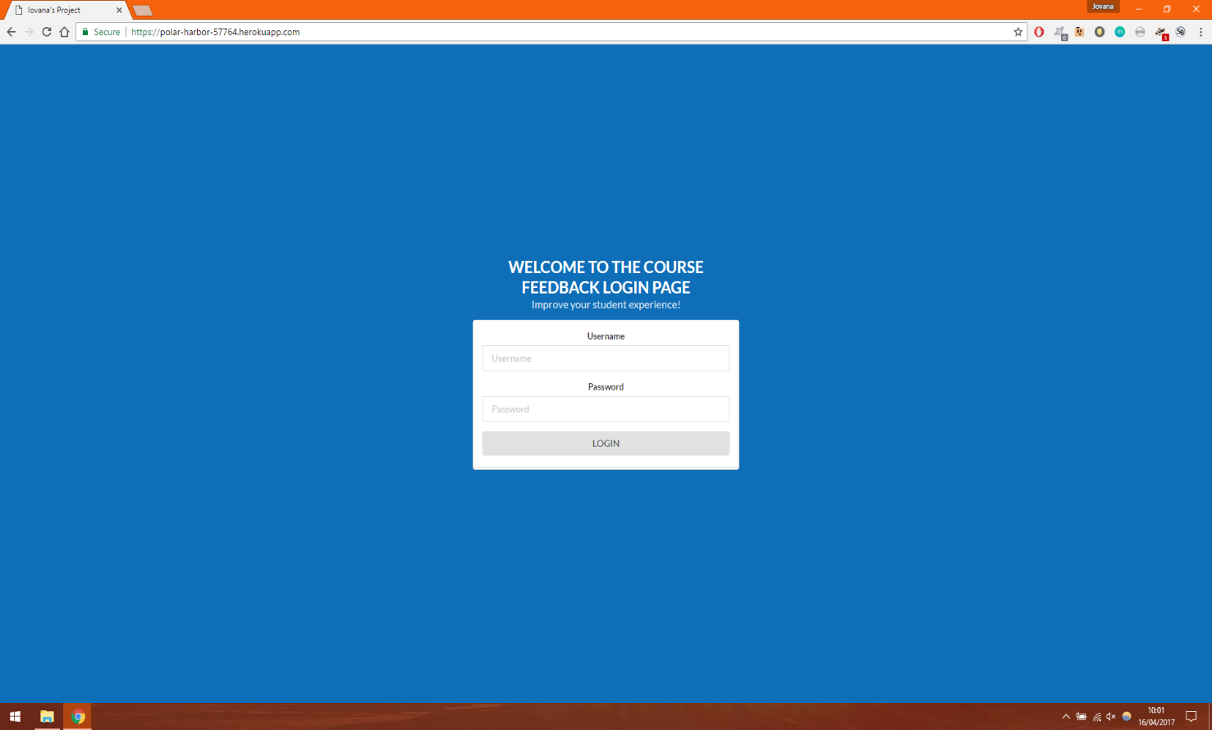

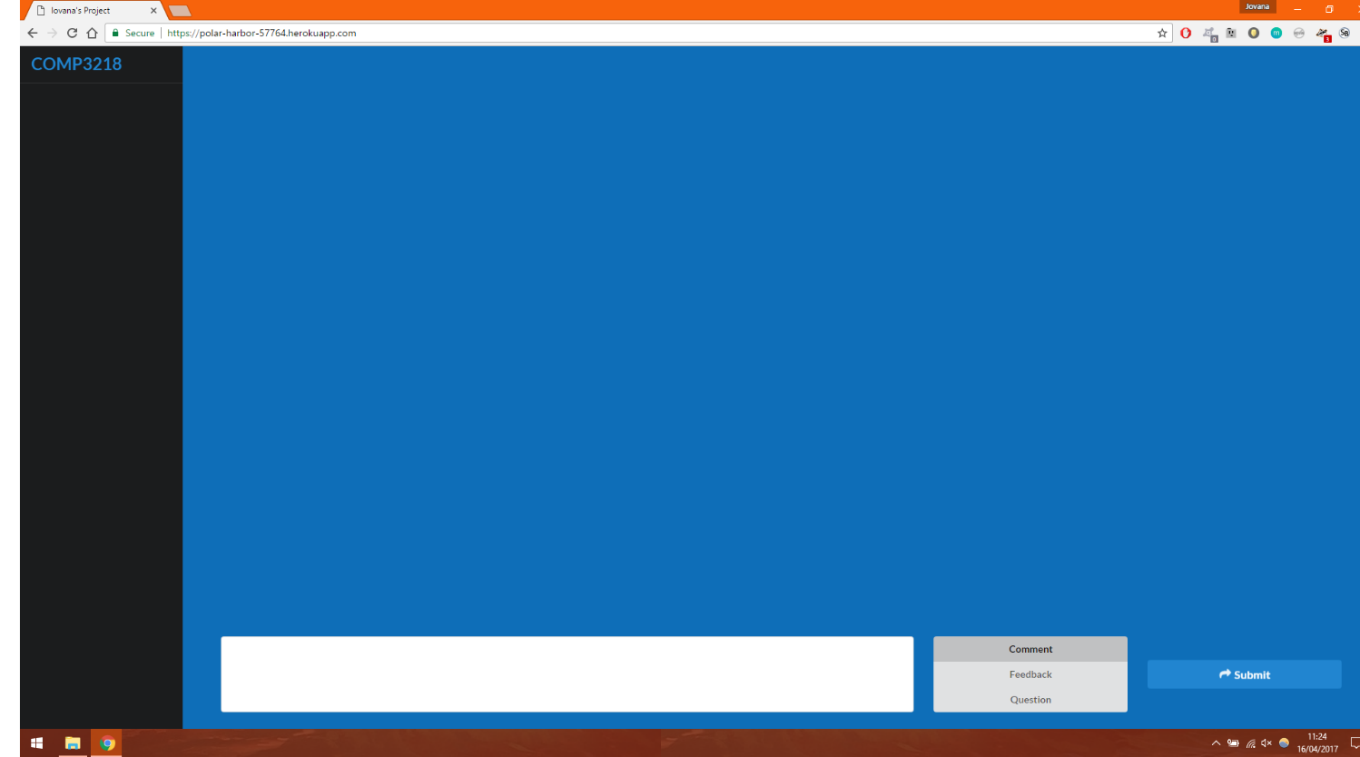Fig. 11 – *Login Page*

Fig. 12 – *Forum Page*